We have the JIRA Dashboard in the below URL where we effectively track all the items related to the Sprint

<https://onejira.verizon.com/secure/Dashboard.jspa?selectPageId=164205#Two-Dimensional-Filter-Statistics/392587>

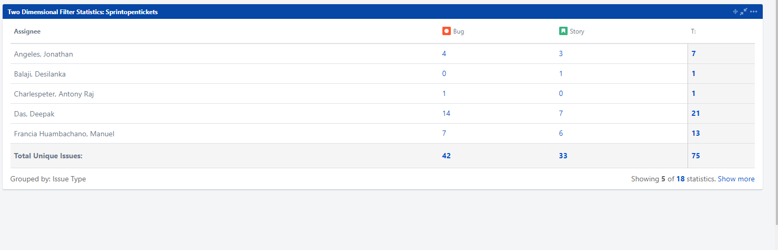

Stories are also tracked for weekly releases based on due dates:  
Release items are tracked through the below link

https://onejira.verizon.com/issues/?filter=368279x

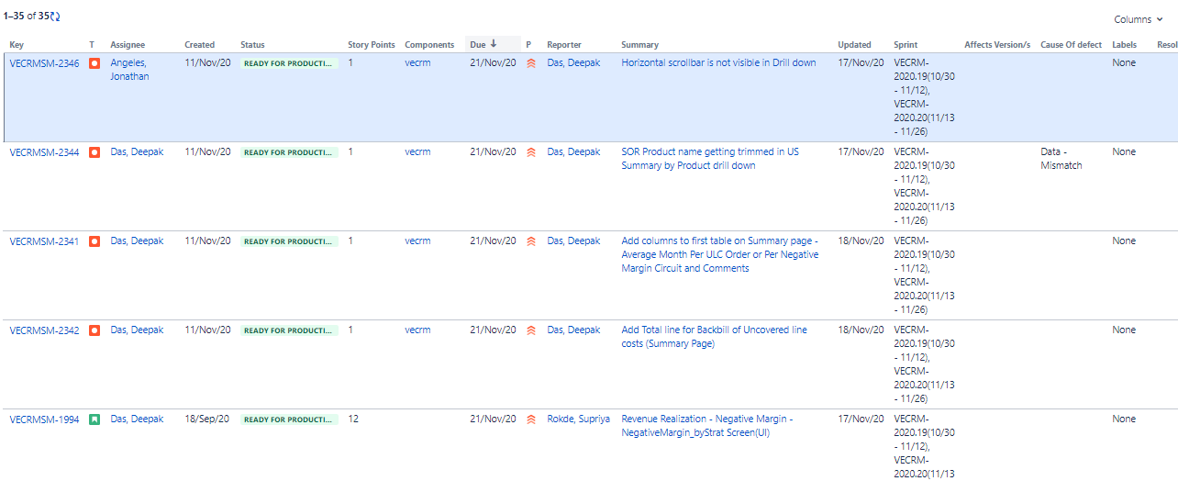

Also we maintain the release items in a central repository for quich reference below is the google drive link

<https://drive.google.com/drive/folders/1EtmRlXHCIGL8RGXxJA0GAbTjXRPi1P8d>

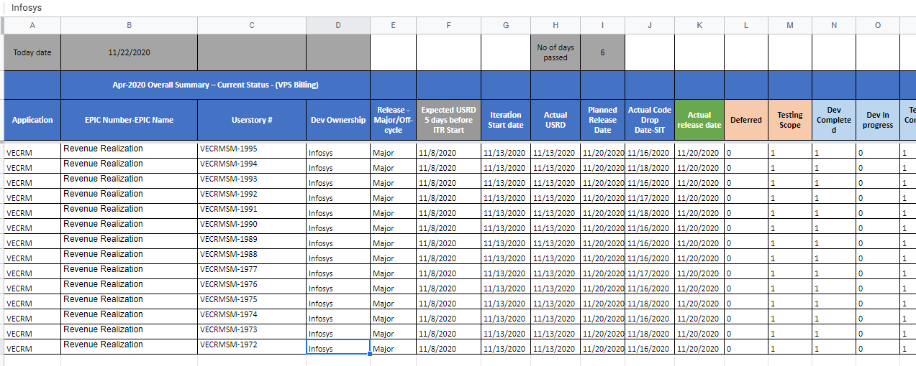

Sprint 18 :

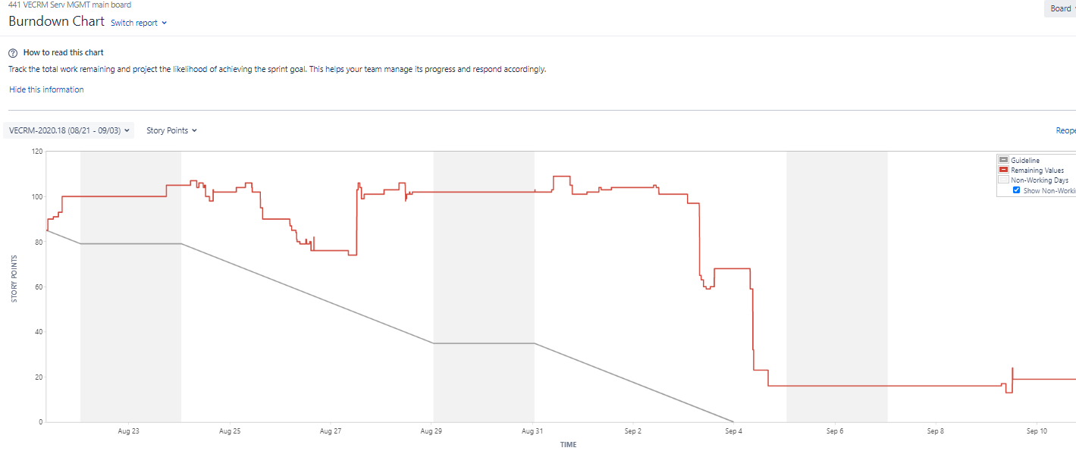

Sprint 19 :

